Software Requirements Specification
for
Cache write policies
Version 1.0 approved
Prepared by
Matteo Zini - 533197
Francesco Paladino - 530271
Raffaele Giannessi - 532978
Giulio Rossolini - 530244
Jacopo Malvatani - 533629

University of Pisa
08/05/2019
Table of Contents
Table of Contents ii
Revision History ii
1. Introduction 1
1.1 Purpose 1
1.2 Product Scope 1
2. Overall Description 1
2.1 Product Perspective 1
2.2 Product Functions 2
3. External Interface Requirements 2
3.1 User Interfaces 2
3.2 Hardware Interfaces 3
3.3 Software Interfaces 3
3.4 Communications Interfaces 3
4. System Features 3
4.1 Miss policies 3
4.1.1 Description and Priority 3
4.1.2 Write-allocate functional requirements 3
4.1.3 Write no-allocate functional requirements 4
4.2 Hit policies 4
4.2.1 Description and Priority 4
4.2.2 Write-back functional requirements 4
4.2.3 Write-through functional requirements 4

Revision History
Name | Date | Reason For Changes | Version
 | 08.05.2019 | First version | 1.0

Introduction

Purpose
<Identify the product whose software requirements are specified in this document, including the revision or release number. Describe the scope of the product that is covered by this SRS, particularly if this SRS describes only part of the system or a single subsystem.>

This document describes the implementation of the cache write policies module. This is a subsystem of the cache, which is part of the microprocessor architecture design.

Product Scope
<Provide a short description of the software being specified and its purpose, including relevant benefits, objectives, and goals. Relate the software to corporate goals or business strategies. If a separate vision and scope document is available, refer to it rather than duplicating its contents here.>

The software is intended to implement all the possible cache write policies in a microprocessor. The implemented policies are: write-through, write-back, write-allocate and write no-allocate.

Overall Description

Product Perspective
<Describe the context and origin of the product being specified in this SRS. For example, state whether this product is a follow-on member of a product family, a replacement for certain existing systems, or a new, self-contained product. If the SRS defines a component of a larger system, relate the requirements of the larger system to the functionality of this software and identify interfaces between the two. A simple diagram that shows the major components of the overall system, subsystem interconnections, and external interfaces can be helpful.>

The module is an extension of the basic 1-way cache module of a typical architecture of a microprocessor. The module is a component of the set-associative cache module which is part of a multilevel cache system. The basic scheme representing the position in the whole architecture of the designed module is shown in the following picture.
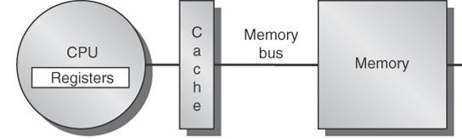

Product Functions
<Summarize the major functions the product must perform or must let the user perform. Details will be provided in Section 3, so only a high level summary (such as a bullet list) is needed here. Organize the functions to make them understandable to any reader of the SRS. A picture of the major groups of related requirements and how they relate, such as a top level data flow diagram or object class diagram, is often effective.>

This module is instantiated by the higher-level set-associative module for every cache way; the caller must provide to the constructor the desired write policy which must be followed.
In order to apply that policy, every write and read operation must be processed by this module and redelivered to the 1-way cache module.

The operations that this module provides are:
- Constructor: decide the write policies
- Read: read a word from the cache
- Write: write a word into the cache

External Interface Requirements

User Interfaces
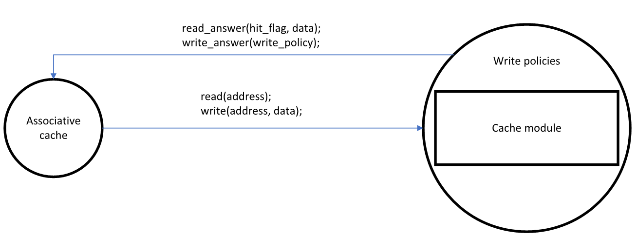
<Describe the logical characteristics of each interface between the software product and the users. This may include sample screen images, any GUI standards or product family style guides that are to be followed, screen layout constraints, standard buttons and functions (e.g., help) that will appear on every screen, keyboard shortcuts, error message display standards, and so on. Define the software components for which a user interface is needed. Details of the user interface design should be documented in a separate user interface specification.>
This module as a C++-class is an extension of the cache module

Software Interfaces
<Describe the connections between this product and other specific software components (name and version), including databases, operating systems, tools, libraries, and integrated commercial components. Identify the data items or messages coming into the system and going out and describe the purpose of each. Describe the services needed and the nature of communications. Refer to documents that describe detailed application programming interface protocols. Identify data that will be shared across software components. If the data sharing mechanism must be implemented in a specific way (for example, use of a global data area in a multitasking operating system), specify this as an implementation constraint.>

This module exchanges messages with the higher-level set-associative module in order to execute the requested operation. To implement this communication, we defined a structure for the request messages and another one for the response messages.

The structure of the request has these fields:
- OpType op_type: this is the type of the requested operation
- uint16_t address: this is the address on which the operation has to be performed
- uint16_t* data: this field contains the data to write

The fields “address” and “data” must be set depending on the “op_type”:
- SET_DIRTY: set the address of the cache line to set dirty
- CHECK_DIRTY: set the address of the cache line whose dirty bit must be checked
- CHECK_VALIDITY_DIRTY: set the address to check
- CHECK_DATA_VALIDITY: set the address to check
- INVALID_LINE: set the address to invalid
- LOAD: set the address of the block to load
- STORE: set the address where to store the block and its data
- WRITE_WITH_POLICIES: set the address where to store the word and its data

The structure of the response has these fields:
- In case of read
  - bool hit_flag
  - uint16_t* data
  - uint16_t address
- In case of write
  - WriteResponse wr

All those fields have different meaning depending on the previously requested “op_type”:
- SET_DIRTY: address of the dirty cache line and the hit flag: 0 if the line is invalid
- CHECK_DIRTY: address of the checked cache line and hit flag: 1 if the line is dirty
- CHECK_VALIDITY_DIRTY: address of the checked cache line and the hit flag: 1 if the line is dirty, 0 either if the line is invalid or if it’s not dirty
- CHECK_DATA_VALIDITY: address of the checked cache line and the hit flag: 1 if the line is valid
- INVALID_LINE: address of the invalidated cache line and the hit flag: 0 if the line was already invalid
- LOAD: address of the requested cache line, hit flag (1 in case of hit) and the read data (null in case of miss)
- STORE: address of the written cache line, hit flag (1 if the block was valid, 0 otherwise)
- WRITE_WITH_POLICIES:
if (hit_flag == 1)
address: the address of the written word
else
if (the block is invalid)
address: the address of the word to be written
else
address: the address of the block which is occupying the requested location
wr: action that the caller must perform, depending on the write policy

The response message structure contains the field wr, which is meaningful when a WRITE_WITH_POLICIES operation was requested. It’s an enum type and its value represents the action the caller must perform in order to meet the chosen write policies
- NOT_NEEDED: this value is returned when the requested operation is not WRITE_WITH_POLICIES
- PROPAGATE: this value is returned when the write-through policy is selected; so, the caller needs to propagate the write operation to the lower-level
- NO_PROPAGATE: this value is returned when the write-back policy is selected; so, the caller doesn’t need to propagate the write operation to the lower-level
- LOAD_RECALL: this value is returned when the write-allocate policy is selected and the block containing the requested word is not in the cache; in order to complete the operation, the caller must load that block before calling the operation again
- CHECK_NEXT: this value is returned when the write-no-allocate policy is selected and the block containing the requested word is not in the cache; in order to complete the operation, the caller must propagate it to the lower-level

Required Interface
<Describe the requirements associated with any communications functions required by this product, including e-mail, web browser, network server communications protocols, electronic forms, and so on. Define any pertinent message formatting. Identify any communication standards that will be used, such as FTP or HTTP. Specify any communication security or encryption issues, data transfer rates, and synchronization mechanisms.>

Since the cache write policies module extends the direct-mapped cache module, this interface is required:
- Load(address) : data
- Store(address, data) : result
- Invalid_line(address) : void
- Check_data_validity(address) : result
- Set_dirty(address, value) : void
- Check_validity_dirty(address) : value
- Resolve_index(address) : index
- Get_tag(address) : tag
- Check_dirty(address) : value
- Check_used(address) : value

System Features
<This template illustrates organizing the functional requirements for the product by system features, the major services provided by the product. You may prefer to organize this section by use case, mode of operation, user class, object class, functional hierarchy, or combinations of these, whatever makes the most logical sense for your product.>

Miss policies

Description and Priority
<Provide a short description of the feature and indicate whether it is of High, Medium, or Low priority. You could also include specific priority component ratings, such as benefit, penalty, cost, and risk (each rated on a relative scale from a low of 1 to a high of 9).>

Through a parameter passed to the constructor of this module, it’s possible to choose between two different behaviors in case of miss:
- Write-allocate
- Write no-allocate

Write-allocate functional requirements
When a word needs to be written, it can happen that there’s not a copy of it in the cache memory. If this policy must be followed, the operation cannot be completed until the word is transferred into the cache. In order to do it, this module replies to the caller with a code which means that before serving the request, it must copy that word into the cache.

Write no-allocate functional requirements
When a word needs to be written, it can happen that there’s not a copy of it in the cache memory. If this policy must be followed, the operation must “skip” the cache, and so it must be directly handled by the main memory. That’s why this module replies with a code which means that the operation must be “propagated” to the lower level in the memory hierarchy.

Hit policies

Description and Priority
Through a parameter passed to the constructor of this module, it’s possible to choose between two different behaviors in case of hit
- Write-back
- Write-through

Write-back functional requirements
When a word needs to be written, it can happen that there’s a copy of it in the cache memory. If this policy must be followed, the word must be written into the correspondent cache location. In this case the word in the main memory is not updated.

Write-through functional requirements
When a word needs to be written, it can happen that there’s a copy of it in the cache memory. If this policy must be followed, the word must be written both into the correspondent cache location and into the lower level in the memory hierarchy.

Operations provided
The cache write policies module provides the following operations.

Set dirty
Given an address, this operation consists of setting the dirty bit of the corresponding cache block only if it’s valid (i.e. the block contains the requested word). In particular, the function check_data_validity belonging to the required interface is called to check if the given block is valid; in case of positive response, its dirty bit is set to 1. Considering the response structure: the hit flag is set to 1 if the cache block was valid, 0 otherwise; the address is set to the address of the given block; the write-response field is set to NOT_NEEDED.

Check validity dirty
Given an address, this operation consists of checking whether the corresponding cache block is valid (i.e. the block contains the requested word) and dirty. In particular, the function check_validity_dirty belonging to the required interface is called to check if the given block is valid and dirty. Considering the response structure: the hit flag is set to 1 if the cache block is both valid and dirty, 0 otherwise; the address is set to the address of the given block; the write-response field is set to NOT_NEEDED.

Check data validity
Given an address, this operation consists of checking whether the corresponding is valid (i.e. the block contains the requested word). In particular, the function check_data_validity belonging to the required interface is called to check if the given block is valid. Considering the response structure: the hit flag is set to 1 if the cache block is valid; the address is set to the address of the given block; the write-response field is set to NOT_NEEDED.

Check dirty
Given an address, this operation consists of checking the dirty bit of the corresponding cache block. In particular, the function check_dirty belonging to the required interface is called to check if the given block is dirty. Considering the response structure: the hit flag is set to 1 if the cache block is dirty; the address is set to the address of the given block; the write-response field is set to NOT_NEEDED.

Invalid line
Given an address, this operation consists of invalidating the corresponding cache block only if it’s valid (i.e. the block contains the requested word). In particular, the function check_data_validity belonging to the required interface is called to check if the given block is valid; in case of positive response, the function invalid_line belonging to the required interface is called to invalidate the given block. Considering the response structure: the hit flag is set to 1 if the cache block was valid; the address is set to the address of the given block; the write-response field is set to NOT_NEEDED.

Load
Given an address, this operation consists of loading the corresponding cache block only if it’s valid (i.e. the block contains the requested word). In particular, the function check_data_validity belonging to the required interface is called to check if the given block is valid; in case of positive response, the function load belonging to the required interface is called to load the given block into an array. Considering the response structure: the hit flag is set to 1 if the cache block was valid (hit), 0 otherwise (miss); the address is set to the address of the given block; the write-response field is set to NOT_NEEDED; the data field is set to the loaded data array only in case of hit, NULL otherwise.

Store
Given an address and a data block whose size is the same of the size of a cache block, this operation consists of storing the given data block into the corresponding cache block. In particular, the function check_data_validity belonging to the required interface is called to check if the corresponding cache block is valid; then, the function set_dirty belonging to the required interface is called to set to 1 the dirty bit of the cache block; finally, the function store belonging to the required interface is called to store the given data block into the corresponding cache block. Considering the response structure: the hit flag is set to 1 if the cache block was valid (hit), 0 otherwise (miss); the address is set to the address of the given block; the write-response field is set to NOT_NEEDED.

Write with policies
IN SOSPESO
Given an address and a data word, this operation consists of storing the given data word into the corresponding cache block, at the corresponding offset (i.e. it modifies only the word in the whole block). In particular, the function check_data_validity belonging to the required interface is called to check if the corresponding cache block is valid. If the response is positive (i.e. in case of hit), the function set_dirty belonging to the required interface is called to set to 1 the dirty bit of the cache block; then, the function load belonging to the required interface is called to load the given data block into an array; afterwards, the given data word is copied at the right position into the loaded cache block; finally, the function store belonging to the required interface is called to store the modified block into the cache. If the response is negative (i.e. in case of miss), Considering the response structure: the hit flag is set to 1 if the cache block was valid (hit), 0 otherwise (miss); the address is set to the address of the given block; the write-response field is set to NOT_NEEDED.

Test case
In order to test the cache write policy module, we simulated in some sense the behavior of the orchestrator module: in particular, we prepared a test file cwp_test.cpp, whose main function calls the onNotify function passing a request message. Also, we modified the function sendWithDelay of the class module, extended by our module: its original behavior is to send the response message to the orchestrator; our version prints the values of the response message structure in order to understand whether the module works correctly or not (debugging with the output).
To make sure to test every possible behavior of the module, the cwp_test.cpp test file instantiates 4 4096-byte caches by using the possible combinations of policies: write-back and write-allocate, write-through and write-allocate, write-back and write-no-allocate, write-through and write-no-allocate.

